Aggregate Volatility Model Results

The following plots show the distribution of the types of models fitted to different states. At the national level we observe almost 50% of the states show GARCH effects, however only about 10% of the states exhibit long memory.

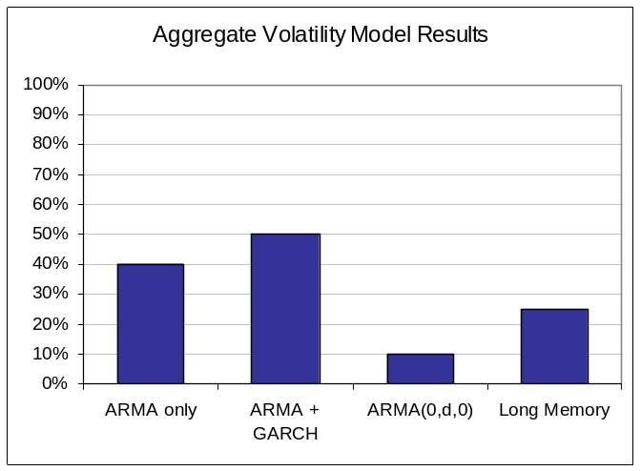
Figure IV.1: Aggregate Volatility Model Results Across States

A decomposition of the aggregate results was carried out to check if the bubble states and the states in the areas majorly affected by the housing crisis showed prominent GARCH effects or long memory in their housing prices. The following plots led us to conclude that there were no distinctive trends in long memory or persistent volatility in housing prices attributable to these states in particular, and the trends closely follow the national level aggregates.

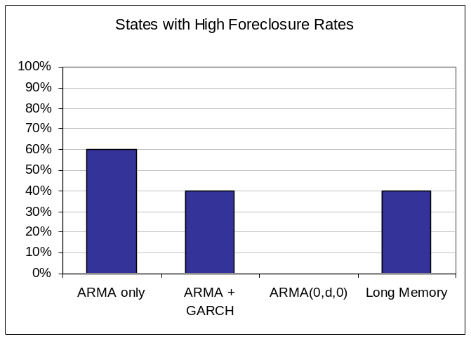
Figure IV.2: Volatility Model Results for States with High Foreclosure Rates

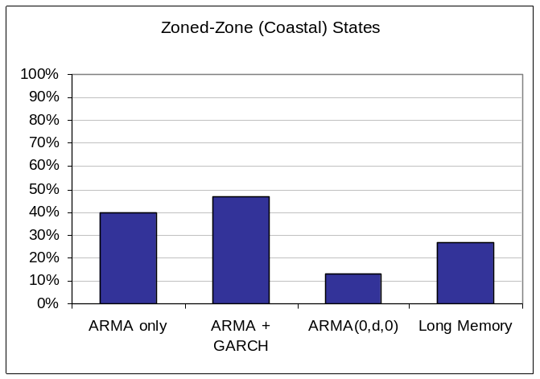
Figure IV.3: Volatility Model Results for Zoned-Zone Coastal States

